Software Design Document (SDD)
GPIO Driver
STM32F411RE Microcontroller
Module | GPIO Driver
Version | 1.0
Authors | David Mijares, Ximena Cedillo, Xavier Clemente
Date | April 27, 2026
Based on | GPIO.h / GPIO.c (STM32F411RE)

1. Introduction

1.1. Purpose
This document describes the design and architecture of the GPIO driver module for the STM32F411RE microcontroller, based on the requirements defined in the Software Requirements Specification (SRS). It provides details on data structures, algorithms, and control flow to guide implementation and testing.

1.2. Scope
The GPIO driver is a low-level software component for embedded systems. It abstracts the STM32F411RE GPIO hardware registers and provides a clean, reusable API for higher-level modules (such as LED and Button modules) to configure, read, and drive digital I/O pins without direct register access.

1.3. Definitions, Acronyms, and Abbreviations
Term | Definition
GPIO | General Purpose Input/Output
MCU | Microcontroller Unit
SRS | Software Requirements Specification
SDD | Software Design Document
API | Application Programming Interface
IDR | Input Data Register (STM32 GPIO)
ODR | Output Data Register (STM32 GPIO)
MODER | GPIO Mode Register (STM32)
BSRR | Bit Set/Reset Register (STM32 GPIO)
RCC | Reset and Clock Control (STM32)
AHB1ENR | AHB1 Peripheral Clock Enable Register
CMSIS | Cortex Microcontroller Software Interface Standard

1.4. Requirements
All functional requirements specific to this module are allocated in the SRS-GPIO_Driver document, available at:
SRS-GPIO_Driver on GitHub

2. System Architecture

2.1. High-Level Design
The GPIO driver follows a layered software architecture:
- Application Layer: Higher-level modules (e.g., LED module, Button module, main application) call the GPIO driver public API functions defined in GPIO.h.
- GPIO Driver Layer: Provides the public API (gpio_init, gpio_initPort, gpio_setPinMode, gpio_setPin, gpio_clearPin, gpio_togglePin, gpio_readPin). Internally maps port enum values to STM32 hardware peripherals.
- Hardware Layer: The actual STM32F411RE GPIO peripheral registers (MODER, ODR, IDR, BSRR) and the RCC AHB1ENR clock enable register.

2.2. Module Interfaces
- Public API: All functions are declared in GPIO.h and defined in GPIO.c.
- Dependencies: CMSIS device header (stm32f4xx.h) providing GPIO_TypeDef, RCC definitions, GPIOA–GPIOH peripheral addresses. Standard library: stdint.h for uint8_t.
- Consumers: LED module, Button module, and any application layer that needs direct GPIO control.

3. Detailed Design

3.1. Class Diagram
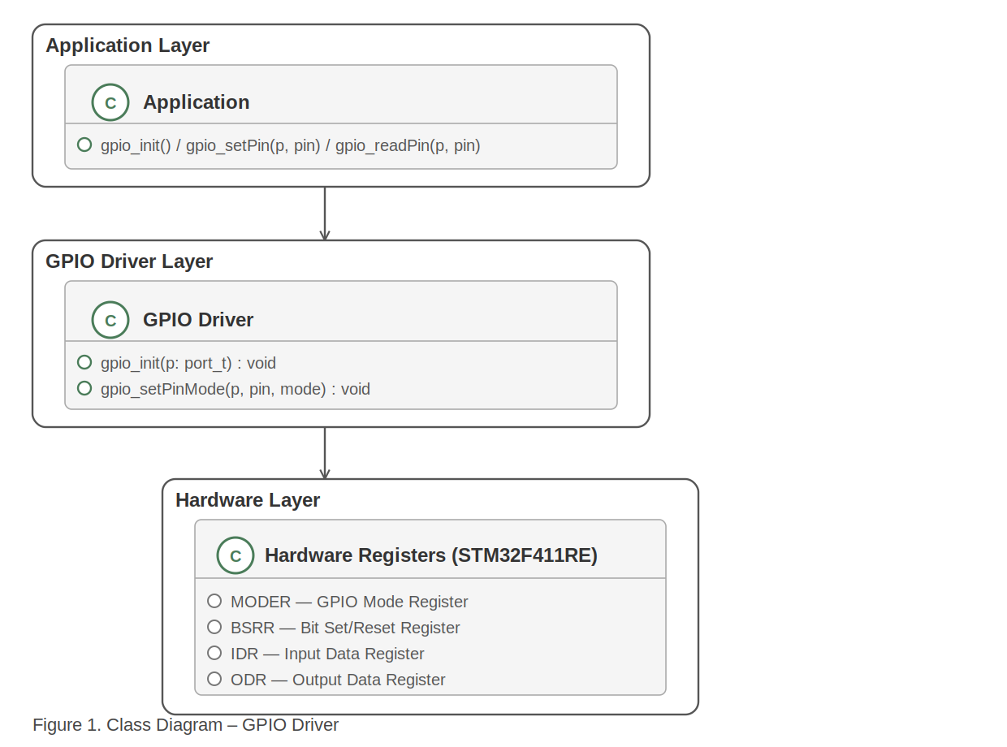
Figure 1. Class Diagram – GPIO Driver

3.2. Module Behavior (Sequence Diagrams, State Machines, etc.)

3.2.1. Sequence Diagram – gpio_init()
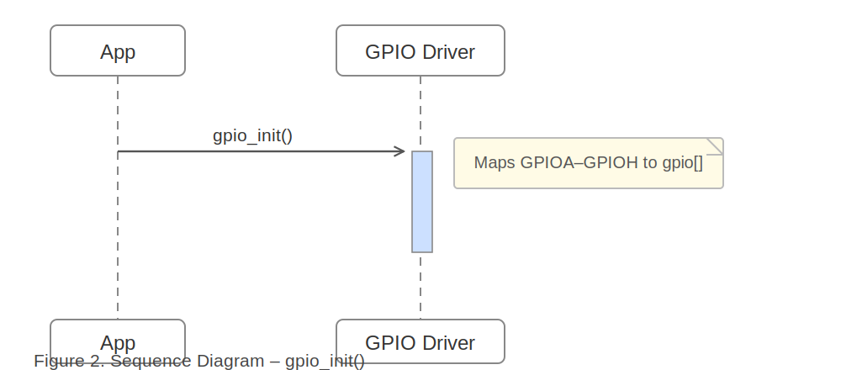
Figure 2. Sequence Diagram – gpio_init()

3.2.2. Activity Diagram – gpio_init()
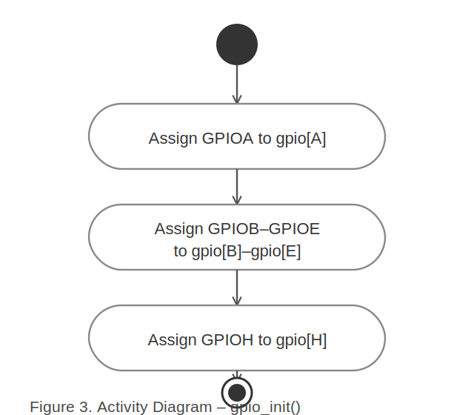
Figure 3. Activity Diagram – gpio_init()

3.2.3. Sequence Diagram – gpio_initPort(p) [Conditional]
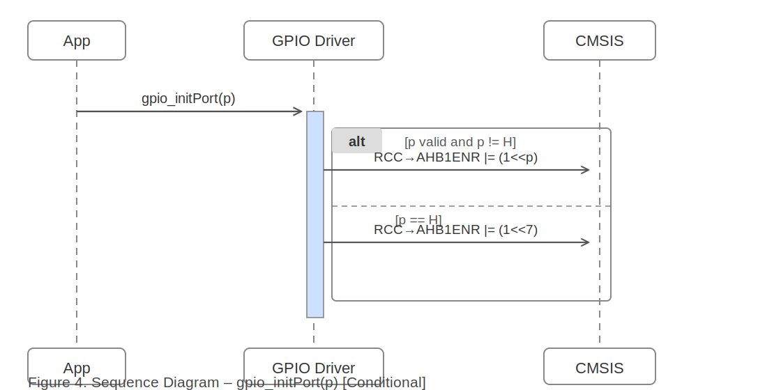
Figure 4. Sequence Diagram – gpio_initPort(p) [Conditional]

3.2.4. Activity Diagram – gpio_initPort(p)
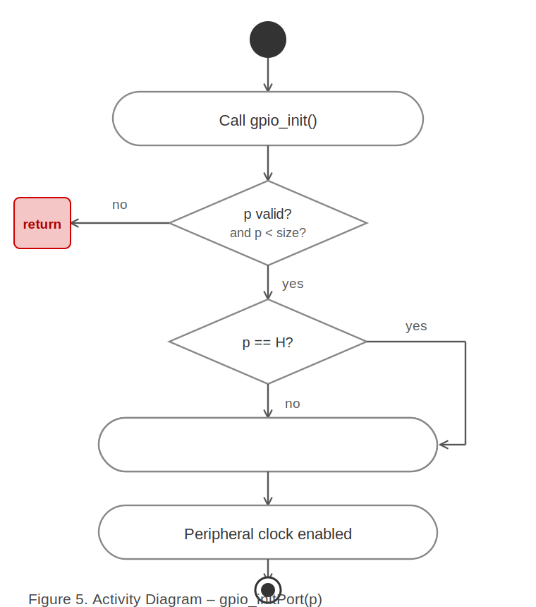
Figure 5. Activity Diagram – gpio_initPort(p)

3.2.5. Sequence Diagram – gpio_readPin(p, pin) [Loop / Conditional]
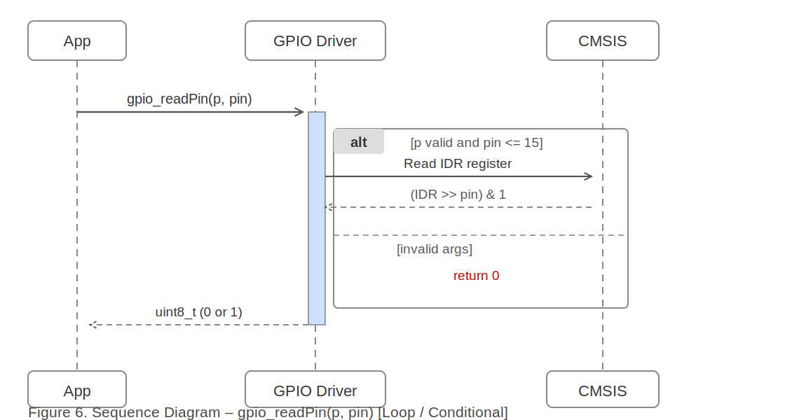
Figure 6. Sequence Diagram – gpio_readPin(p, pin) [Loop / Conditional]

3.2.6. Activity Diagram – gpio_readPin(p, pin)
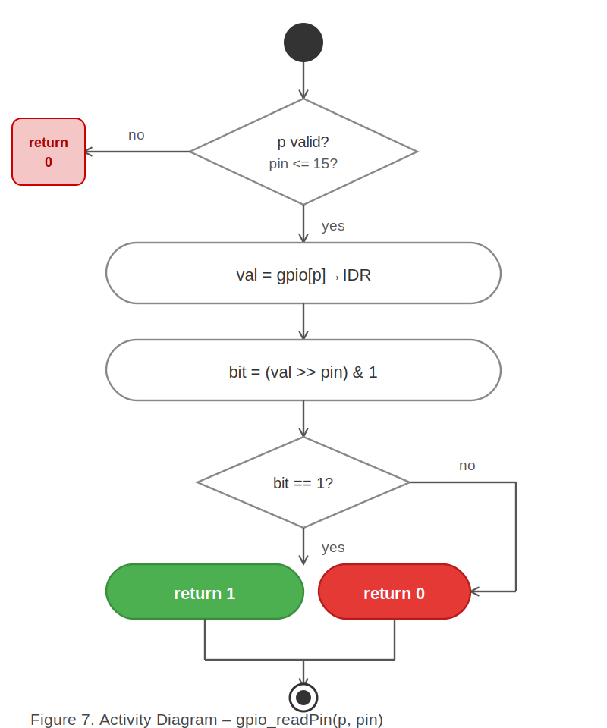
Figure 7. Activity Diagram – gpio_readPin(p, pin)

3.2.7. State Diagram – GPIO Pin Lifecycle
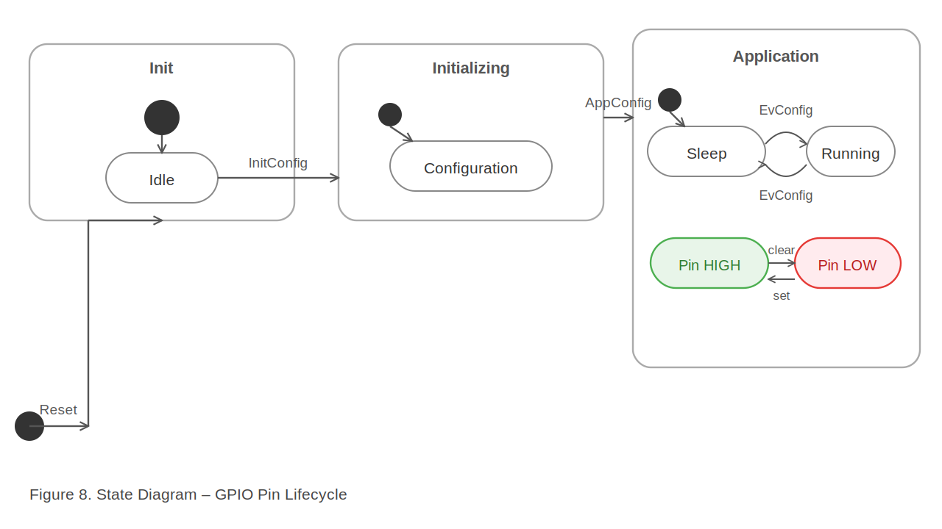
Figure 8. State Diagram – GPIO Pin Lifecycle

3.3. GPIO Driver Description
The GPIO driver provides a hardware abstraction layer over the STM32F411RE General Purpose I/O subsystem. The internal state is a global array gpio[size] of type GPIO_TypeDef*, indexed by the port_t enumeration (A=0 through H=5). The gpio_init() function (Figure 2, Figure 3) populates this array by assigning the hardware base addresses GPIOA–GPIOH.

Before any pin operation, gpio_initPort(p) (Figure 4, Figure 5) must be called. It validates the port argument, handles the GPIOH special case (which uses AHB1ENR bit 7 instead of bit 5), calls gpio_init() to ensure the array is populated, and enables the peripheral clock via RCC->AHB1ENR |= (1UL << p).

Pin direction is set by gpio_setPinMode(p, pin, mode), which writes the 2-bit mode value into the MODER register at position pin*2. Supported mode values are: 0 (input), 1 (output), 2 (alternate function), 3 (analog).

Output operations use the BSRR register for atomic, glitch-free pin set/clear. gpio_setPin() writes to the lower 16 bits (bits [15:0]), while gpio_clearPin() writes to the upper 16 bits (bits [31:16]) by adding 16 to the pin index. Toggle is achieved by XOR-ing the ODR bit. Input reading (Figure 6, Figure 7) samples the IDR register once and returns 0 or 1. Invalid arguments always cause an early return (for void functions) or return 0 (for gpio_readPin), as shown in Figure 8.

4. Application Programming Interfaces

4.1. Data Types and Macros
port_t (enum): This enumeration represents the available GPIO port identifiers for the STM32F411RE. It maps A–H to integer indices 0–5, and includes size = 6 as the array bound sentinel.

Member Name | Type | Notes / Definition
A, B, C, D, E, H | enum value (int) | Maps port letter to array index (0–5).
size | enum value = 6 | Array bound; total number of supported ports.

GPIO_TypeDef* gpio[size]: A global array of pointers to GPIO peripheral base addresses. Populated by gpio_init(). Declared extern in GPIO.h for use by the driver only.

No preprocessor macros are defined in this driver. Hardware constants are provided by the CMSIS stm32f4xx.h header.

4.2. Error Codes
The GPIO APIs use the following return conventions. Functions returning void do not provide error codes; invalid arguments cause an early return.

Code / Value | Definition
void (no return) | gpio_init, gpio_initPort, gpio_setPinMode, gpio_setPin, gpio_clearPin, gpio_togglePin return void. Invalid arguments cause early return (no error code).
0 (uint8_t) | gpio_readPin returns 0 when pin is LOW, or when invalid port/pin arguments are provided.
1 (uint8_t) | gpio_readPin returns 1 when pin is HIGH.

4.3. Function Definitions

gpio_init
Function Name | gpio_init
Syntax | void gpio_init(void)
Parameters (in) | None | —
Parameters (inout) | None | —
Parameters (out) | None | —
Return value | void | No return value.
Description | Initializes the GPIO subsystem by mapping all STM32F411RE GPIO ports (A–H) to the internal gpio[] array. Must be called before any port-specific operations, or is called internally by gpio_initPort().
Constraints | Does not enable any peripheral clocks. Does not configure any registers. Must be followed by gpio_initPort() before pins can be used.
Available via | GPIO.h

gpio_initPort
Function Name | gpio_initPort
Syntax | void gpio_initPort(port_t p)
Parameters (in) | p : port_t | The GPIO port to initialize. Valid values: A, B, C, D, E, H (enum port_t).
Parameters (inout) | None | —
Parameters (out) | None | —
Return value | void | No return value.
Description | Enables the peripheral clock for the specified GPIO port via RCC->AHB1ENR. Internally calls gpio_init() to populate the gpio[] array. For port H, remaps the index from 5 to 7 to match the correct AHB1ENR bit position.
Constraints | If p is out of range (< 0 or > 6), the function returns immediately without any action. Does not configure individual pin modes.
Available via | GPIO.h

gpio_setPinMode
Function Name | gpio_setPinMode
Syntax | void gpio_setPinMode(port_t p, uint8_t pin, uint8_t mode)
Parameters (in) | p : port_t, pin : uint8_t, mode : uint8_t | p = target port; pin = pin number [0..15]; mode = MODER value [0..3] (0=input, 1=output, 2=alt, 3=analog).
Parameters (inout) | None | —
Parameters (out) | None | —
Return value | void | No return value.
Description | Configures the mode of the specified pin on the given GPIO port by writing to the MODER register. Clears the existing 2-bit mode field and sets the new value.
Constraints | Returns immediately if p > 6, mode > 3, or pin > 15. Clock must be enabled via gpio_initPort() before calling.
Available via | GPIO.h

gpio_setPin
Function Name | gpio_setPin
Syntax | void gpio_setPin(port_t p, uint8_t pin)
Parameters (in) | p : port_t, pin : uint8_t | p = target port; pin = pin number [0..15].
Parameters (inout) | None | —
Parameters (out) | None | —
Return value | void | No return value.
Description | Drives the specified GPIO pin to logic HIGH by writing to the lower 16 bits of the BSRR register. This is an atomic operation.
Constraints | Returns immediately if p > 6 or pin > 15. Pin must be configured as output first.
Available via | GPIO.h

gpio_clearPin
Function Name | gpio_clearPin
Syntax | void gpio_clearPin(port_t p, uint8_t pin)
Parameters (in) | p : port_t, pin : uint8_t | p = target port; pin = pin number [0..15].
Parameters (inout) | None | —
Parameters (out) | None | —
Return value | void | No return value.
Description | Drives the specified GPIO pin to logic LOW by writing to the upper 16 bits (bits [31:16]) of the BSRR register (pin + 16). This is an atomic operation.
Constraints | Returns immediately if p > 6 or pin > 15. Pin must be configured as output first.
Available via | GPIO.h

gpio_togglePin
Function Name | gpio_togglePin
Syntax | void gpio_togglePin(port_t p, uint8_t pin)
Parameters (in) | p : port_t, pin : uint8_t | p = target port; pin = pin number [0..15].
Parameters (inout) | None | —
Parameters (out) | None | —
Return value | void | No return value.
Description | Inverts the current logical state of the specified GPIO pin by XOR-ing the corresponding bit in the ODR register.
Constraints | Returns immediately if p > 6 or pin > 15. This operation is NOT atomic (read-modify-write on ODR). Use in interrupt-safe context only.
Available via | GPIO.h

gpio_readPin
Function Name | gpio_readPin
Syntax | uint8_t gpio_readPin(port_t p, uint8_t pin)
Parameters (in) | p : port_t, pin : uint8_t | p = target port; pin = pin number [0..15].
Parameters (inout) | None | —
Parameters (out) | None | —
Return value | uint8_t | Returns 1 if pin is HIGH, 0 if pin is LOW or arguments are invalid.
Description | Reads the digital state of the specified GPIO pin by sampling the IDR register once and checking the bit at position pin.
Constraints | Returns 0 for invalid arguments (does not distinguish between LOW state and error). The IDR is sampled once — no debounce or repeated reads.
Available via | GPIO.h

4.4. Internal Function Definitions
This driver has no private internal helper functions beyond those exposed in the public API. All logic is contained within the seven public functions described in Section 4.3.

5. Future Enhancements
- Add interrupt support: Implement gpio_enableInterrupt(port_t p, uint8_t pin, trigger_t edge) using EXTI and SYSCFG registers.
- Atomic toggle: Replace ODR XOR with a BSRR-based conditional toggle to make gpio_togglePin() interrupt-safe.
- Pull-up/pull-down configuration: Add gpio_setPullMode(port_t p, uint8_t pin, uint8_t pull) to configure PUPDR register.
- Output speed and type: Add gpio_setOutputType() and gpio_setOutputSpeed() to configure OTYPER and OSPEEDR registers.
- Return error codes: Replace void returns with a gpio_status_t enum (GPIO_OK, GPIO_ERR_INVALID_PORT, GPIO_ERR_INVALID_PIN, etc.) for better error traceability.
- Alternate function configuration: Add gpio_setAltFunction(port_t p, uint8_t pin, uint8_t af) using AFRL/AFRH registers for UART, SPI, I2C, etc.
- Thread safety: Add critical section macros (e.g., disable/re-enable interrupts) around ODR read-modify-write operations.

